**OFFICIAL LANGUAGES OF THE UN**

**https://24x7offshoring.com/**

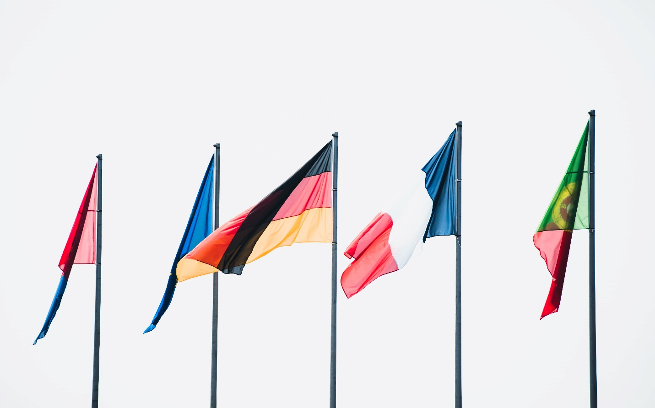 [**http://24x7outsourcing.com/**](http://24x7outsourcing.com/)

**Investigating the Official Languages of the United Nations**

The United Nations is a worldwide association that appeared in 1945. The motivation behind the United Nations is to keep harmony on the planet.

The main nations that partook in its development are France, the Republic of China, the USA, the Soviet Union, and the UK alongside 46 different nations. Every one of these countries intend to assist non-industrial nations with increasing their living expectations, advance social advancement, and basic liberties all throughout the planet.

**Significant Languages of the United Nations**

The 193 individuals from the UN address various populaces of the world that communicate in heterogeneous dialects yet the UN has six authority dialects. These incorporate Arabic, Chinese, French, English, Russian, and Spanish. Arabic is included later. These six authority dialects are utilized at UN gatherings and for true records. These dialects portray 2.8 billion individuals from around the globe. These are additionally the authority dialects of individuals from UN countries.

**Understanding and Translation**

The individuals from the UN are needed to communicate in the language from six authority dialects. Besides, they need to give an understanding of the language that they are utilizing. The understanding is done in the other five authority dialects. The authority records in the UN are treated in a similar way. They should be deciphered and interpreted in the other five dialects. Else, they are not distributed.

**Official Languages of the United Nations**

**English**

English is a broadly communicated in language on the planet. It is local to 1.5 billion individuals altogether and this number is required to increment enormously in the coming years. One inquiry that strikes a chord is the reason English is viewed as a worldwide language. English began to spread in the time of the British Empire and afterward spread in the entire mainland.

**Chinese**

The Chinese language turned into the authority language of the United States in 1946. In its underlying years, Chinese was not utilized in crafted by the United Nations. Ultimately, when the legitimate privileges of the People's Republic of China were reestablished in 1971, at that point the circumstance began improving. In 1973, the overall gathering included Chinese as a functioning language and the Security Council began utilizing it in 1974. As of now, increasingly more UN staff individuals and workplaces are utilizing the Chinese language.

**French**

Albeit all authority dialects are perceived, the UN secretariat has two working dialects, English, French for day by day business correspondence. The UN secretary needs to convey in these two languages.

French is a significant language in the UN however it isn't the favored one. French-talking gatherings and nations need to keep up balance in the UN framework and expertise of the French language is significant in catering another degree of worldwide choices.

**Russian**

The Russian Federation was fruitful in winning its seat after the disintegration of the Soviet Union in 1991. The progression was upheld by the USSR's previous individuals and isn't protested by the UN participation. Russia was liable for the Soviet Union's economy. This factor settled on him the sensible decision of the United Nations.

**Spanish**

Spanish stands firm on an incredible footing in the United Nations framework. Albeit the institutional portrayal is sub-par compared to English and French. The interest for the Spanish language inside the United Nations and outside it predicts the extraordinary future and acknowledgment of the Spanish language.

**OFFICIAL LANGUAGES OF THE UN**

**https://24x7offshoring.com/**

**http://24x7outsourcing.com/**